**ECR**

1. Create your own ECR repo

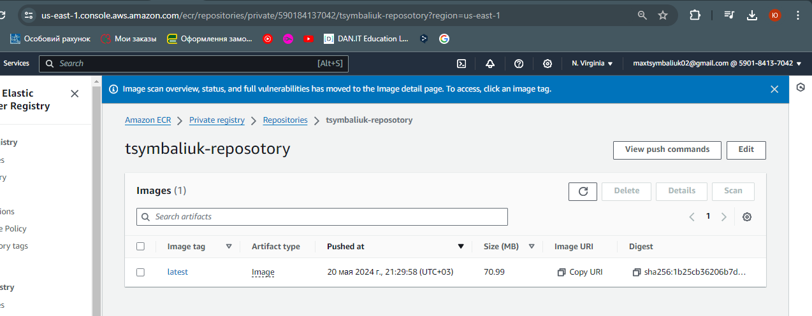

1. Build your custom image on your laptop or in ec2

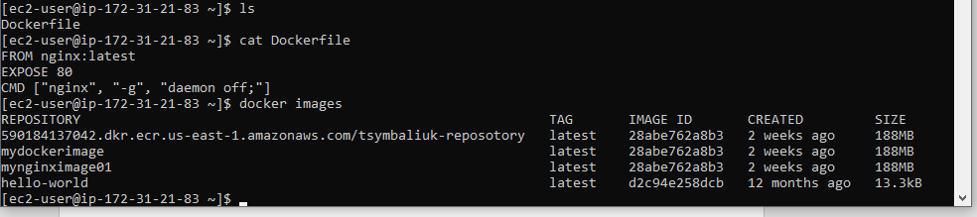

1. Login to ECR repo

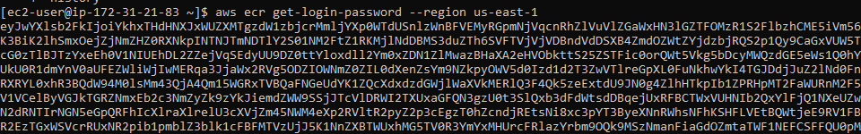

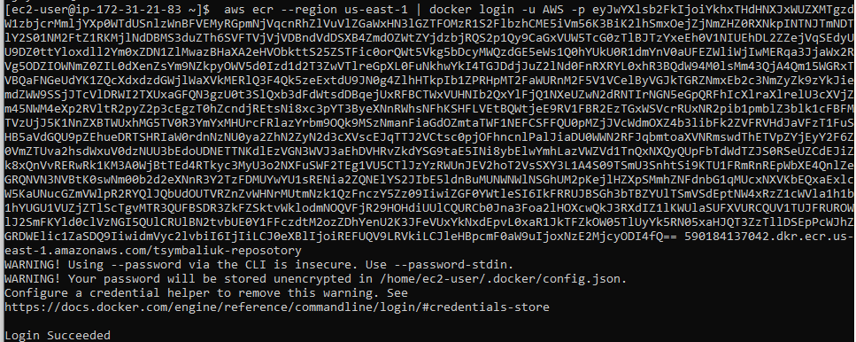

1. Push image to ECR

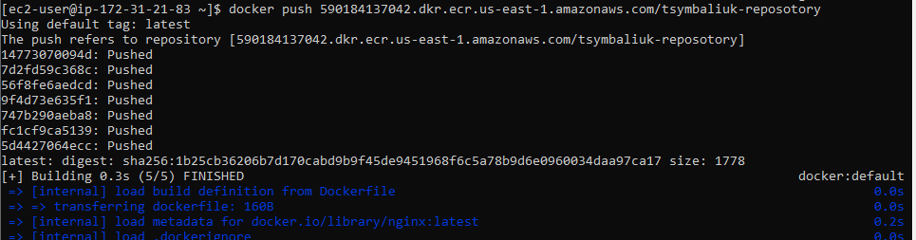

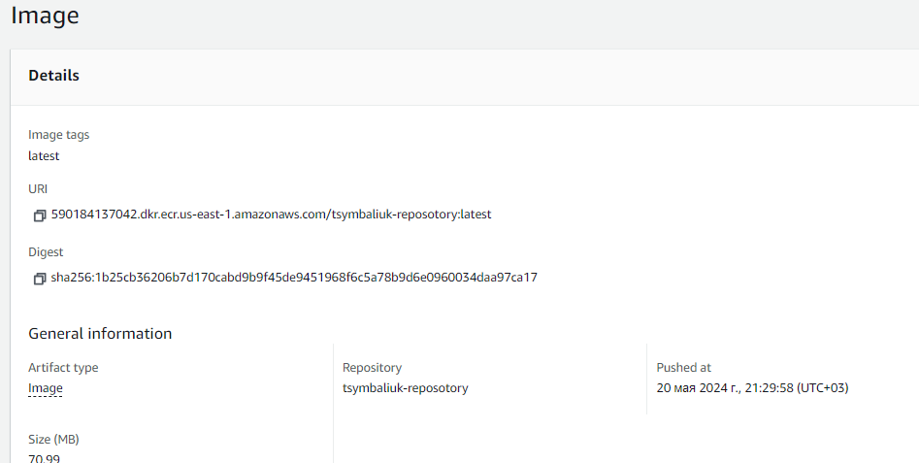

1. Delete ECR

Done!

**ElastiCache (not full)**

1. Create elasticache cluster

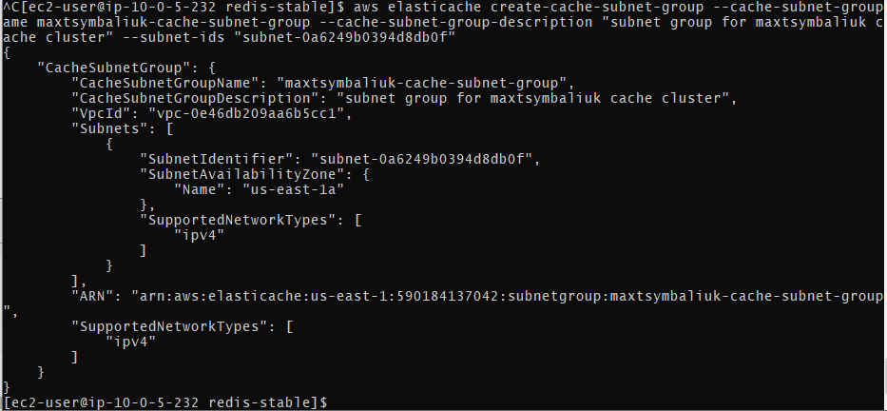

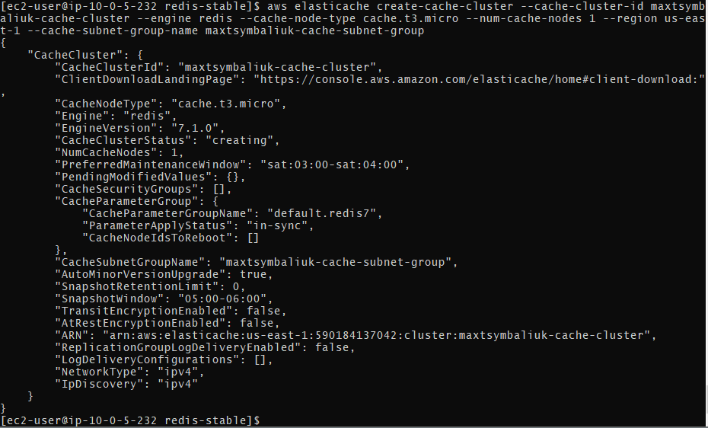

1. Create ec2 instance and provide policy which will allow this specifc ec2 access to your specific cluster
2. Install redic-cli or run redis container from the instance and connect to cache cluster

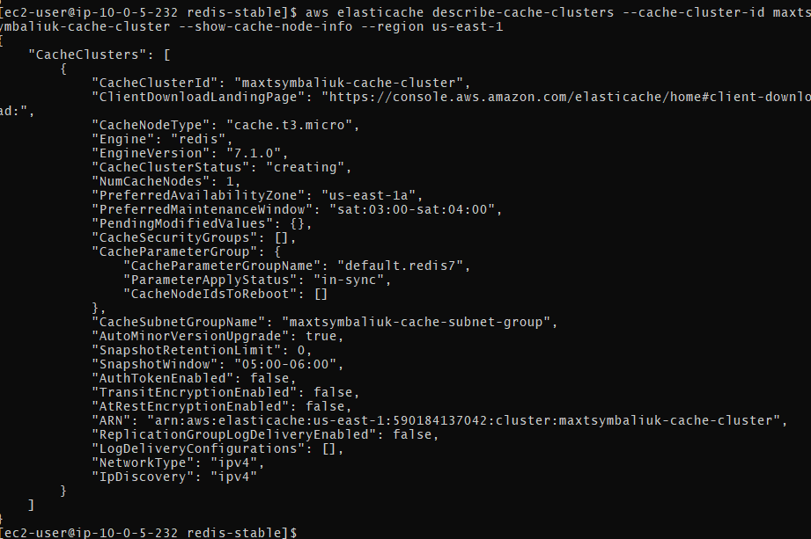



1. Put a few values to DB and get them
2. Delete elasticache cluster, ec2, ec2 policy

**SNS**

1. Create SNS topic

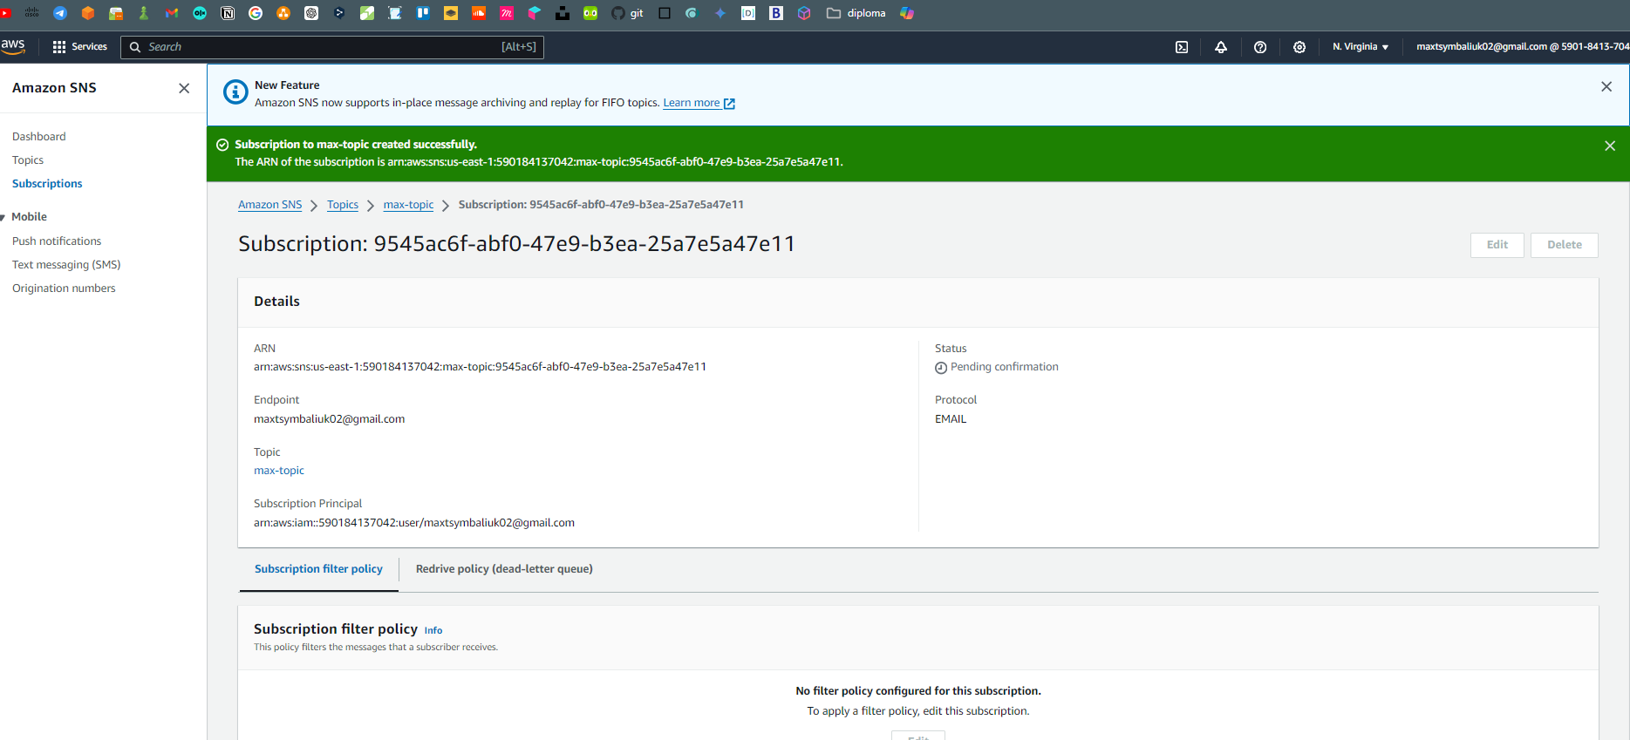

1. Subscribe your email to notifications

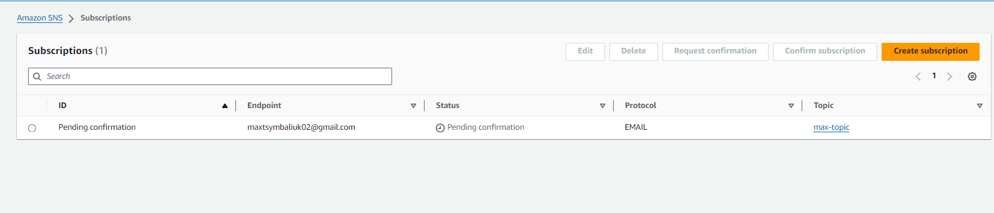

1. Send message from web console to the topic

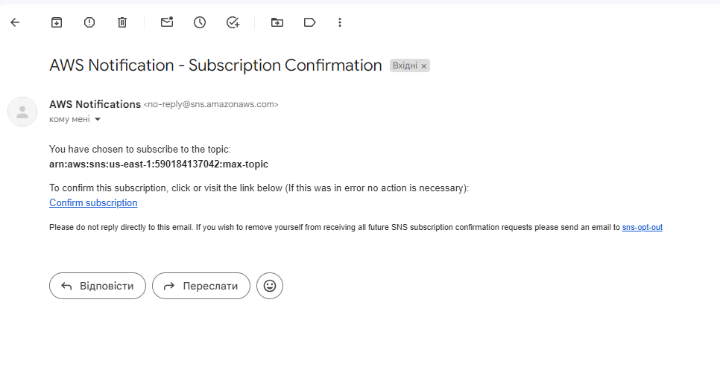

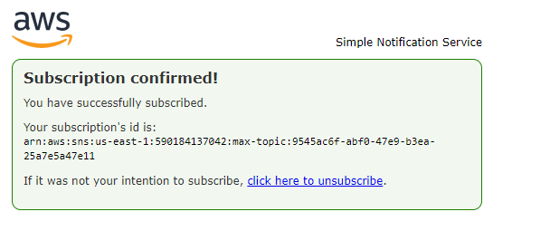

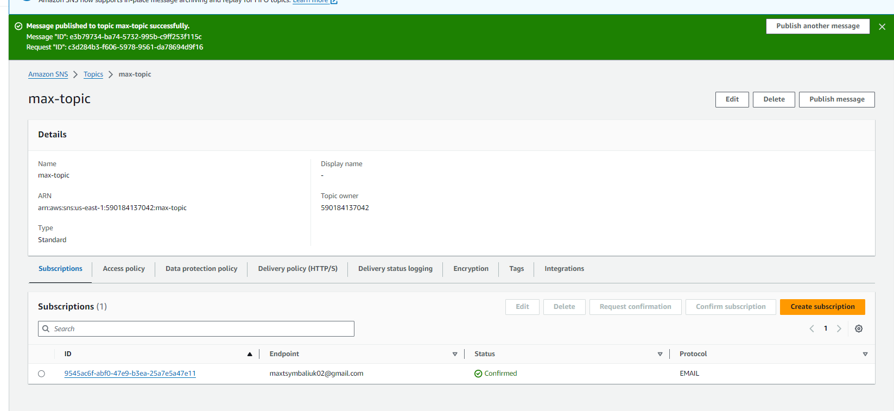

1. Send message from aws cli



1. Confirm that you've got both messages

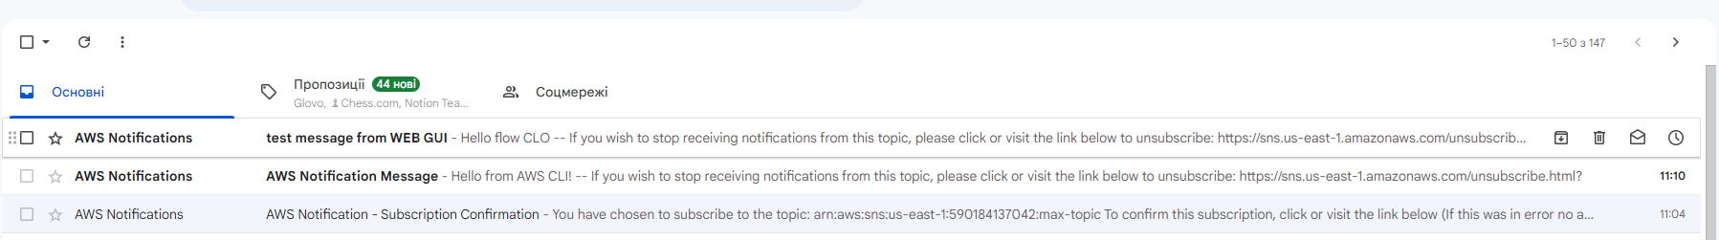

1. Delete topic

done

**SQS**

1. Create SQS queue

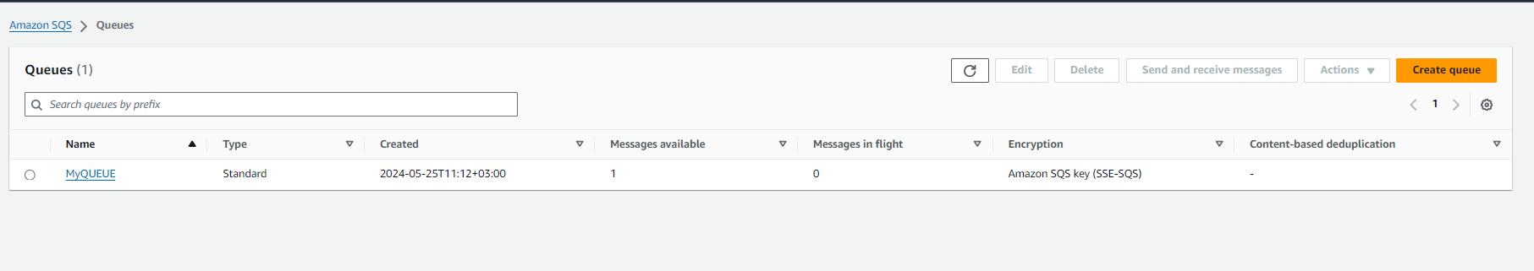

1. Send message from web console to the queue

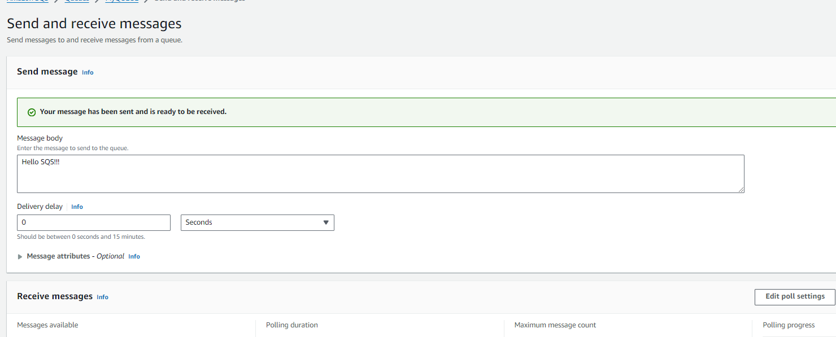

1. Get message from aws cli

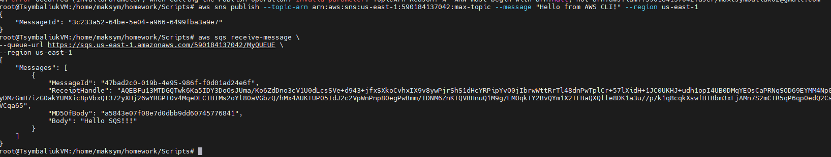

1. Send message from aws cli

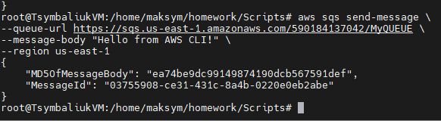

1. Get message from web interface

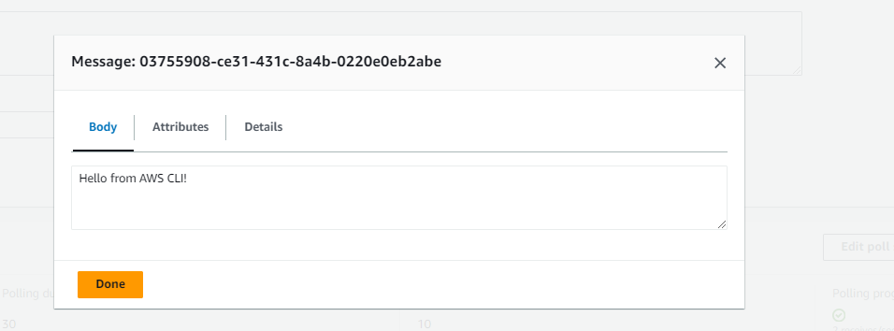

1. Delete topic

done

**Secrets**

1. Create secret from the web console

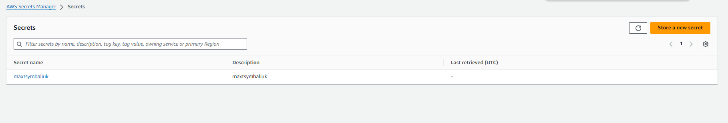

1. Get secret value from aws cli

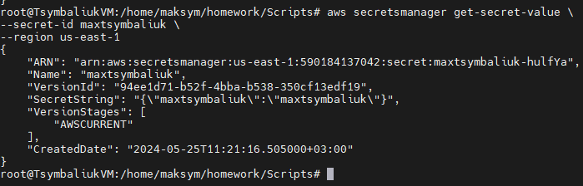

1. Change secret value from aws cli

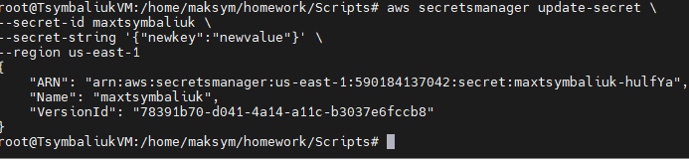

1. Get updated value from web console

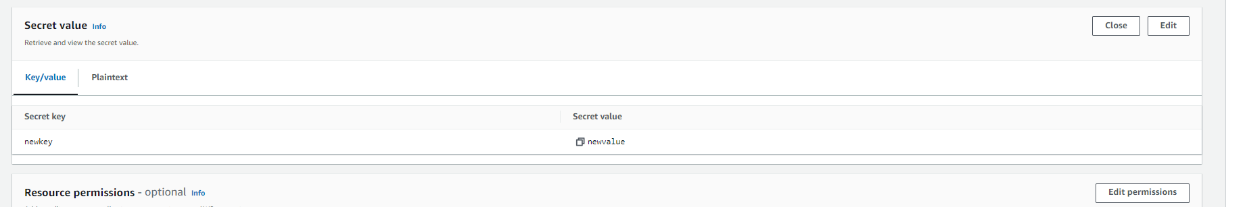

1. Delete secret from aws cli without retention period

